System Requirements Document
(SRD)
for
Wrist Blood Pressure Monitoring System
(WBPMS)

Author: Alex YIN
Date: 05/05/2015
Table of Contents 4
1 General 5
1.1 Purpose & Scope 5
1.2 document Contributors 5
1.3 Document revision History 5
1.4 Change Record 5
2 Executive Summary 6
2.1 Background 6
2.1.1 Problem Statement 6
2.1.2 High Level Project Description 6
2.1.3 Goals and Objectives 6
2.1.4 Benefits 6
2.2 Justification 6
2.2.1 Market Positioning, Drivers and Assumptions 6
2.2.2 Cost Analysis and Estimates 6
2.2.3 Formulas Used 6
2.2.4 Explain Saving Calculations 6
2.2.5 Reduction in Head Count/Turnover 6
2.2.6 Amount of Revenue Generated 6
2.2.7 What Period of Time to Achieve Savings 6
2.2.8 Who will be responsible for achieving results 6
2.2.9 Mandates/Other 6
2.2.10 Project Criticality 6
2.3 User Communities 6
2.4 Requested implementation date 6
2.5 Funding 6
3 Project Overview 7
3.1 Functional Overview 7
3.2 Use Cases 7
4 Project Requirements 7
4.1 General 7
4.2 Network elements 7
4.2.1 User Equipment 7
4.2.2 Target, Host 7
4.2.3 To be Discussed 7
4.3 Interfaces, Protocols and Messages 7
4.4 Mobility 7
4.5 Faults, Configuration, Accounting, Performance, andSecurity (FCAPS) 7
4.5.1 Fault Management 7
4.5.2 Configuration Management 7
4.5.3 Accounting and Billing 7
4.5.4 Performance, Capacity & Operation Measurements 7
4.5.5 Security 7
4.6 Services 8
4.7 Inter-Operability Testing (IOT) 8
4.8 Prepaid 8
4.9 Roaming 8
4.10 Considerations 8
4.11 User Interface 8
4.12 Call Processing 8
4.13 Customer Care 8
5 Testing 8
6 Deliverables 8
7 Compliance 8
8 References 8
9 Definitions 8
9.1 Acronyms 8
9.2 Interfaces 8
10 Approval Page 8
List of Figures 8

General

Purpose & Scope

The purpose of this System Requirements Document (SRD) is to provide a high-level description of the requirements for Wrist Blood Pressure Monitoring System (WBPMS). This document will be used to guide the development, delivery and testing of the Project as requested. The document will identify critical interfaces, and functionality requirements necessary to implement the Project.
The Vendor shall serve as the primary vendor for development of the requirements described in this document.
All parties are expected to comply with the terms of the non-disclosure agreement. The content of this document is considered CDMA-OAM-LDD proprietary and its confidentiality is reserved.

document Contributors
This Section provides the list of those personnel responsible for the definition of this Project request. Ultimate responsibility for the completeness and accuracy of all requirements contained in this document belongs to the author. The Impacted Group(s) is responsible for facilitating requirement development and clarification.
Disclaimer: Contributor names left off of this list is unintentional. Please contact the author in order to correct such oversight.
Name | Role/Area | Phone
Alex YIN | SE | 27425937
Snow XU | Dev | 27425949
Cherry AN | Dev | 27425973
Liam YUAN | Dev | 27425912

Document revision History
Version | Date | Changed By | Description of Change
1.0 | 5/2/2015 | Alex YIN | Initial version

Executive Summary
This Section describes Project background information, business drivers, user communities, time-critical implementation pre-requisites such as training, approved funding, facility and resource and any other pertinent information that helps in defining this Project.

Background
Wrist Blood Pressure Monitor System (WBPMS) is a system

Problem Statement
WBPMS provide a solution to cover this gap.

High Level Project Description

Goals and Objectives
Our goal is to implement WBPMS based on Linux kernel 2.6.39, to provide the capability of catching and displaying the peoples’ blood pressure data in real-time from UT and transferring to UE, and while meeting the special UT specification ,standards and protocols.

Benefits
With WBPMS, Sprint can accelerate VoLTE time to market, and realize the user experience and network
efficiency advantages offered by VoLTE until LTE coverage is built out to match the full geographic range of their subscriber service commitments.

Justification

Market Positioning, Drivers and Assumptions

Cost Analysis and Estimates

Formulas Used

Explain Saving Calculations

Reduction in Head Count/Turnover

Amount of Revenue Generated

What Period of Time to Achieve Savings

Who will be responsible for achieving results

Mandates/Other

Project Criticality

User Communities

Requested implementation date
Stable Software load is due early 3Q 2015
SRVCC available for market deployment (GA) by early 4Q 2015
Service Launch by 1Q 2016

Funding

Project Overview

Functional Overview
SRVCC offers LTE-IMS based voice service within the LTE coverage area, and CS-based voice service
outside the LTE coverage area. Whenever the VoLTE subscriber moves out of LTE coverage, SRVCC
ensures smooth handoff of voice from the LTE to the CS network.
As with any new handover technologies, SRVCC requires additional functionality in both the source (LTE) system
and the target (legacy) system. The SRVCC architecture for E-UTRAN to 3GPP2 1xCS is shown in Error!
Reference source not found.. SRVCC architecture for 3GPP2 1xCS reuses many existing elements in 3GPP2 X.S0042 [4] for 3GPP2 1xCS.

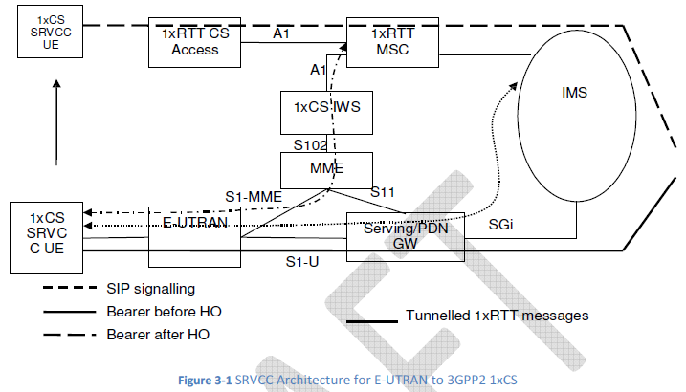
1. The solution shall allow coexistence and be compatible with the 1xCS procedures specified in the 3GPP2 VCC
specification, X.S0042 [4].
2. The solution shall not require UE with multiple RATs capability to simultaneously signal on two different
RATs.
3. The solution shall be transparent to E-UTRA only terminal or network.
4. The solution shall minimize the coupling between the E-UTRAN and the 3GPP2 access. In particular, the
solution shall allow the cdma2000 1xRTT specification to evolve without necessitating a modification to the EUTRAN
specifications.
5. RAT change and domain selection should be under network control.
6. In roaming cases, the Visited PLMN should control the RAT change and/or domain selection while taking
into account any related HPLMN policies.
7. The solution shall not impact cdma2000 RAT.
8. The solution shall not impact cdma2000 CS CN.
9. All IMS sessions that may be subject to SRVCC shall be anchored in the IMS (VCC Application).
10. When SRVCC is deployed, QCI=1:
Shall not be used for IMS sessions that are not anchored in the IMS (VCC Application); and
Shall only be used for the voice bearer.

Use Cases

Project Requirements
The following subsections cover the requirements to enable SRVCC solution in Sprint Network.
Note: Work items for Standards body are identified throughout the text with underlined, italicized font.

General

Network elements

User Equipment
Changed ID | Date | Requirement | Comments

Target, Host
Changed ID | Date | Requirement | Comments

To be Discussed
Changed ID | Date | Requirement | Comments

Interfaces, Protocols and Messages

Mobility

Faults, Configuration, Accounting, Performance, andSecurity (FCAPS)
This section addresses the same topics previously known as Operations, Alarms/Administration, Maintenance, Performance (OAM&P).

Fault Management
Changed ID | Date | Requirement | Comments

Configuration Management
Changed ID | Date | Requirement | Comments

Accounting and Billing
Changed ID | Date | Requirement | Comments

Performance, Capacity & Operation Measurements
Changed ID | Date | Requirement | Comments

Security
Changed ID | Date | Requirement | Comments

Services
Changed ID | Date | Requirement | Comments

Inter-Operability Testing (IOT)
Changed ID | Date | Requirement | Comments

Prepaid
Changed ID | Date | Requirement | Comments

Roaming
Changed ID | Date | Requirement | Comments

Considerations

User Interface

Call Processing

Customer Care

Testing

Deliverables

Compliance

References
Title | Location

Definitions

Acronyms
Acronym | Meaning

Interfaces

Approval Page

List of Figures

